









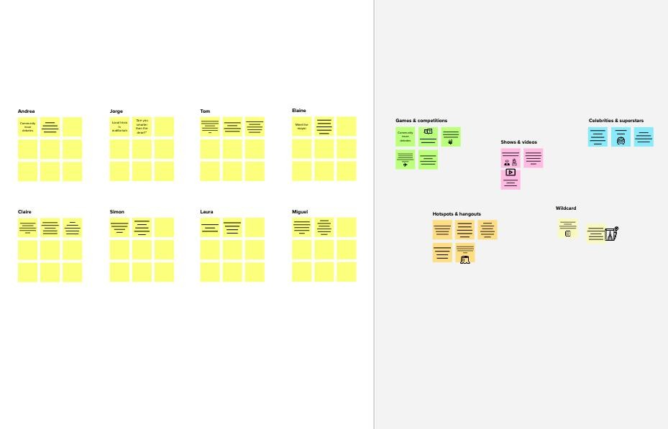


3

Groupideas
Taketurnssharingyourideaswhileclusteringsimilarorrelatednotesasyougo.Onceallstickyno teshavebeengrouped,giveeachclusterasentence- likelabel.Ifaclusterisbiggerthansixstickynotes,tryandseeifyouandbreakitupintosmallersu b-groups.
4

Prioritize
Your team should all be on the same page about what's importantmoving forward. Place your ideas on this grid to determine whichideas are important and which are feasible.
Afteryou collaborate
You can export the mural as an image or pdfto share with members of your company whomight find it helpful.
20minutes
Quickadd-ons
electric vehicles
another integralaspect ofmoving forwardis patience
movingforwardmeansn ot to accept thecalamities of life tobreak you .it meansthatyouarewillin gtocontinue even duringtimes of greatdifficulties
ASharethemural Shareaviewlinktothemuralwithstakeholderstokeepthem in the loop about the outcomes of the session.
BExportthemural ExportacopyofthemuralasaPNGorPDFtoattachtoemails, include in slides, or save in your drive.

Keepmovingforward
Strategyblueprint
Definethecomponentsofanewideaorstrategy.
charging scenario
barriersof electrical vehicle
optimizationt echnique
youdonotallow external circumstanceto stop you from the prusuit of yourgoals
Openthetemplate

Customerexperiencejourneymap
Understandcustomerneeds,motivations,andobs tacles for an experience.
Openthetemplate
- hybridelectricvehicle
  - serieshybrid 2.parallel
3.powersplithybrid
>.pluginhybridelectrcve hicle
>.batteryelectricvehicle
- businesas usual
- nationalev policies
- market
- technical 3.policy
4.infrastructure
- electric vehicle
- vehicleto grid
Importance
Ifeachofthesetask scouldgetdonewit houtanydifficulty orcost,whichwould havethemostpositi veimpact?
Strengths,weaknesses,opportunities&threats
Identifystrengths,weaknesses,opportunities,and threats (SWOT) to develop a plan.
Openthetemplate

Sharetemplatefeedback
you may findyourselfconfront edwithdauntingobta cles that arealmostimpossible totackle
Feasibility
Regardless of their importance, which tasks are morefeasiblethanothers?(Cost,time,effort,complexity,etc.)

t ldgoont r
y
oldingt ard.

TIP
Participants can use theircursors to point a wherestickynotesshou he grid. The facilitato canconfirm the spot b usingthelaserpointerh
heH key on the keybo

vehicle type

TIP
Addcustomizabletagstostickyno testomakeiteasiertofind,brows e,organize,andcategorizeimpor tantideasasthemeswithinyourm ural.

Needsomei nspiration?
Seeafinishedversionof thistemplatetokicksta rtyourwork.

Open example
Ifpossible,bevisual.
Gofor volume.
Listentoothers.
Deferjudgment.
Encouragewildideas.
Stayintopic.
Keyrulesof brainstorming
Torunansmoothandproductivesession
PROBLEM
Howmightwe[yourproblem statement]?
1

Defineyourproblemstatement
What problem are you trying to solve? Frame yourproblemasaHowMightWestatement.Thiswillbethef ocus of your brainstorm.

5minutes
CLearnhowtousethefacilitationtools
Use the Facilitation Superpowers to run a happy andproductivesession.

Openarticle
BSetthegoal
Thinkabouttheproblemyou'llbefocusingonsolvinginthebrai nstormingsession.
ATeamgathering
Define who should participate in the session and send aninvite. Share relevant information or pre-work ahead.
Beforeyoucollaborate
Alittlebitofpreparationgoesalongwaywith this session. Here’s what you needto do to get going.
10minutes

tersthatperformanceof
thec a relectr ic ca r is leweightcalculatedbyusi
2.overalldimensionac ldiametercapacityandits
4.enginecapacityoffi

str on gs c ien tific te s researchand
innovationability isthemost
im por ta ntfa c to rest
s la 's su c c es sin th e m arket
he
priceand
are
o most valuedfactor

BUSSINESSREQUIREMENTStheele
FORANALYZINGFORoptimal PERFORMANCEAND
EFFICIENCY OFELECTRICis exa CARSANDBRANDSALSOanalyzi
IDENTIFYINGPATTERNSactua ANDTRENDSOVERTIMEIDENT IFYINGAFFECTINGFACTORS
GURU
NAGARAJU
HARSHITHA
ABID

TIP
You can select a sticky noteand hit the pencil [switch tosketch]icontostartdrawing!
2

Brainstorm
Writedownanyideasthatcometomindthat address your problem statement.

10minutes
Brainstorm &ideaprioritization
Use this template in your ownbrainstorming sessions so your teamcan unleash their imagination andstartshapingconceptsevenifyou'ren ot sitting in the same room.
Person1
Person2
Person3
Person4
ctricalvehiclemoreovert performances
o
ng thevehicles automony
mined by
l speed ,input
drivespeedand thetw
a
drivingcycledata
akey performanceparame parameterisadescrib e characteristic 1.vehic
function,requirement
changewouldhavemaj orimpact
ordesign basicthat3.whee
ng
ars battery
cial range
e
a
electricmotorsproducep eaktorque fromastandsti ll,withoutbuildup gasoline
la to o k a
a
unique approach to
a blish itself
enginerequire to reachmaximumpowerfo rte
10minutestoprepare 1hourtocollaborate
2-8peoplerecommended
Person 5
Person6
Person7
Person8
Sharetemplatefeedback
e
c
v
a
Template

effectsan ele,cctrliicmatec carsrange  - hills, electriccarselec tr o  arenotbigfanofhills  - coldtemperatureproble  - lotsofacceleration | ba tte ry issue ntrolsconvertover 77%  ,a n din car  n ics a r e ene rg y fr om the am o n g t h e biggest  minelectricgr idto p ow e r  vehicles | electricvehicles ofthe electrical  t  the wheels
elec tr ic tra c tio n lates  m oto ris th em a in electr  co m p on the ele c tric a lalgorith  vehicle | ttechnologyin oth er innovativ  icalvehiclesare fe a tu re s that  smart electrical vehicle  n ts of charging,selfhealingtes l ms,EV batterynon product  technology,smart  batterymanagementrelate  ve ra ge morecoil ern electric  ha v e an ncyof3to  3.5milesperkwheffici | e  o ffe r s on d
te sla 'sm issionisov er toacceleratethe,mod world stra ns itionc a rs  tosustainableefficie energy |  | makemotorsmo re  ent

mostEVbatteriesha ve alife  expectancyof15batte to2 0 yea rsw ithin curre thecarandaavailabl  seco ndbey ondte sla | themost powerfulelectriceffi  ryis  ntly makebetteruse e isthe  m odel | dcmotor ismore ient thanan  ac motor as they  ofinput energy
thecostof  whenbat replacinganreach t electriccarstheir w  batteryis 15000-  2000 0rupeespe rkwh | EVdonot require  terysdo heend of orkinglife  they willberecyc  ehicleair fa s t cha rg in g of conditioning  systemalsofeature canr anevaporatorand  nserjustcapacityofterjust ny cars | oilwhichisnecessar y tolubricate thenumberof movingpartsinthec ombustion engine
EVb atte ry selectric degrade due  to the  temperatureaconde  ,c yc lea nd tim e lik ea |  | electricbatteries uin their  25 charges

ele ctr icca rs are  alm os ta utom a tic th meaningthey  do no th a ve a clutch ch  fo rc ha n g ing g e a r  ar ee ve na g e a r reg box | eydoneed12Vfortheleadac theircoolantbatt angedonabetween400-  ularbasisforthelithiumion | EVbatteryvoltageis  id  eryand typically somewhere  800V  battery
anhigher voltage systemallowsalowerthe irb  current to beusedmorerar whenchargingtheelectric  batterywhich reduce  overheating andallowsbe exp  betterpowerretensionsyste m | a tte r y need  e metalsareintrinsically ca rsc a n sa fe rtha n vehicl  ensive tointernal combust buy | ele ct ric vehicles  s  poweredby  ion  engines
environm enta l  fr ien d lya s s en se o theydo not  em itp o llu t a n t s w h e | EV cou ld make goodfinancial  v er quickerthan  time,especially n g a s prices  arehigh | EVisoften gasoline  cars

